2)
a)
#include <iostream>
using namespace std;

void merge(int arr[], int l, int m, int r) {
int n1 = m - l + 1;
int n2 = r - m;

int L[n1], R[n2];

for (int i = 0; i < n1; i++)
L[i] = arr[l + i];
for (int j = 0; j < n2; j++)
R[j] = arr[m + 1 + j];

int i = 0, j = 0, k = l;

while (i < n1 && j < n2) {
if (L[i] <= R[j])
arr[k++] = L[i++];
else
arr[k++] = R[j++];
}

while (i < n1)
arr[k++] = L[i++];

while (j < n2)
arr[k++] = R[j++];
}

void mergeSort(int arr[], int l, int r) {
if (l < r) {
int m = (l + r) / 2;
mergeSort(arr, l, m);
mergeSort(arr, m + 1, r);
merge(arr, l, m, r);
}
}

int main() {
int arr[] = {12, 11, 13, 5, 6, 7};
int n = sizeof(arr) / sizeof(arr[0]);

mergeSort(arr, 0, n - 1);

cout << "Sorted array: ";
for (int i = 0; i < n; i++)
cout << arr[i] << " ";

return 0;
}
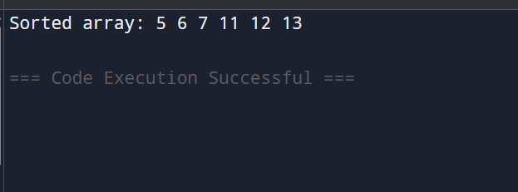
b)
#include <iostream>
using namespace std;

void merge(int arr[], int l, int m, int r) {
int n1 = m - l + 1;
int n2 = r - m;

int L[n1], R[n2];

for (int i = 0; i < n1; i++)
L[i] = arr[l + i];
for (int j = 0; j < n2; j++)
R[j] = arr[m + 1 + j];

int i = 0, j = 0, k = l;

while (i < n1 && j < n2) {
if (L[i] <= R[j])
arr[k++] = L[i++];
else
arr[k++] = R[j++];
}

while (i < n1)
arr[k++] = L[i++];

while (j < n2)
arr[k++] = R[j++];
}

void mergeSort(int arr[], int l, int r) {
if (l < r) {
int m = (l + r) / 2;
mergeSort(arr, l, m);
mergeSort(arr, m + 1, r);
merge(arr, l, m, r);
}
}
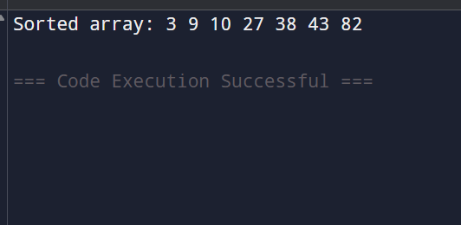

int main() {
int arr[] = {38, 27, 43, 3, 9, 82, 10};
int n = sizeof(arr) / sizeof(arr[0]);

mergeSort(arr, 0, n - 1);

cout << "Sorted array: ";
for (int i = 0; i < n; i++)
cout << arr[i] << " ";

return 0;
}

